**3-bit encoder with Sampling Time = 0.25sec:**

* 2^3 = 8 levels

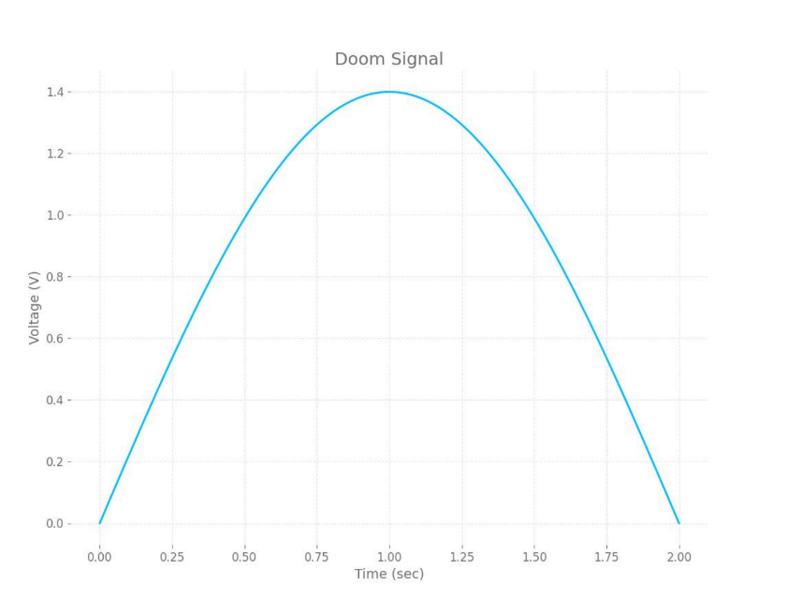



Bit sequence = 000011101110111110101011000

**3-bit encoder with Sampling Time = 0.5sec:**

* 2^3 = 8 levels





Bit sequence = 000101111101000

**3-bit encoder with Sampling Time = 1sec:**

* 2^3 = 8 levels





Bit sequence = 000111000

**2-bit encoder with Sampling Time = 0.25sec:**

* 2^2 = 4 levels



Bit sequence = 00011011100100

**CONCLUSION:**

From the problems above, as the sampling times increase, the accuracy of the signal decreases but it takes up less memory space.

Also, more bits allow for more precise quantization with more levels as level = 2 ^ no of bits. Therefore, leading to more accurate digital representation of the analogue signal. But in doing so, more memory space will be taken.